# Second MapReduce project using KeyValueTextInputFormat

In this project, we will use another input format in MapReduce – *KeyValueTextInputFormat*. Let’s create a file *keyvalue* that contain the data of *gender,name,age,score* as:

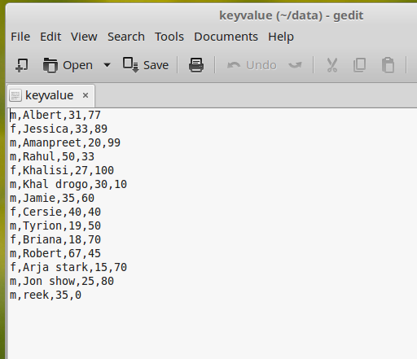

* Use Case for the project
  + We need to find Average-Score Gender-wise
* Now put this file in HDFS
* KeyValueTextInputFormat
  + We use this format for structured data i.e. data where there is some structure like in our example it is comma delimited values – *gender,name,age,score*
  + In this input format type, the part before the first delimiter becomes the key and rest becomes value, see below:

Key – *gender*

Value – *name,age,score*

* Next is to create the bare-bone or bare minimum code structure for our MapReduce project (refer *First MapReduce project*).
  + We will name our package *keyvalue*
* Set the properties in Driver class, see below
  + Create Configuration object so as to use keyvalueinputtextformat

Configuration conf = new Configuration();

* + Comma delimited

conf.set("mapreduce.input.keyvaluelinerecordreader.key.value.separator", ",");

* + Singleton instance of the Job class, passing the Configuration object created earlier

Job job = Job.getInstance(conf);

* + We will set Job Name using setJobByName property. And we will set the setJarByClass property (we will use this property when we run the MapReduce job from Terminal).

job.setJobName("keyvalue");

job.setJarByClass(getClass());

* + Set Mapper class

job.setMapperClass(Map.class);

* + Set Reducer class

job.setReducerClass(Reduce.class);

* + Set the datatype of Key that Mapper outputs

job.setMapOutputKeyClass(Text.class);

* + Set the datatype of value that Mapper outputs

job.setMapOutputValueClass(IntWritable.class);

* + Set the datatype of Key that Reducer outputs

job.setOutputKeyClass(Text.class);

* + Set the datatype of value that Reducer outputs

job.setOutputValueClass(FloatWritable.class);

* + Set InputFormat class to KeyValueTextInputFormat

job.setInputFormatClass(KeyValueTextInputFormat.class);

* + Set the path of Input file to process

FileInputFormat.setInputPaths(job, new Path(arg0[0]));

* + Set the path of Final Output

FileOutputFormat.setOutputPath(job, new Path(arg0[1]));

* + Wait for completion of the Job

return job.waitForCompletion(true) ? 1 : 0;

* Let’s go to our Map class
  + Change the placeholders as:
    - KEYIN to Text
    - VALUEIN to Text
    - KEYOUT to Text
    - VALUEOUT to IntWritable
  + Based on our Use Case, the map method code is below:

public void map(Text key, Text value, Context context)

{

try

{

String[] values = value.toString().split(",");

context.write(key, new IntWritable(Integer.parseInt(values[2])));

}

catch(Exception e)

{

System.out.println(e.getMessage());

}

}

* Now let’s go to the Reduce class.
  + Change the placeholders as:
    - KEYIN to Text
    - VALUEIN to IntWritable
    - KEYOUT to Text
    - VALUEOUT to FloatWritable
  + Based on our Use Case, the reduce method code is below:

public void reduce(Text key, Iterable<IntWritable> values, Context context)

{

try

{

long totalScore = 0L;

int count = 0;

for (IntWritable value : values)

{

totalScore += value.get();

count++;

}

context.write(key, new FloatWritable((float)totalScore/count));

}

catch(Exception e)

{

System.out.println(e.getMessage());

}

}

* Now is the time to run our MapReduce program
  + Right-click on package -> Run As -> Run Configurations
  + Double-click *Java Applications* and select the Application created
    - Under *Arguments* tab, put below in *Program Arguments* and click *Apply*

*hdfs://localhost:9000/datakeyvalue/keyvalue hdfs://localhost:9000/keyvalue*

* + Now click *Run* to run the MapReduce job
  + After the job is executed, see the output in */keyvalue*

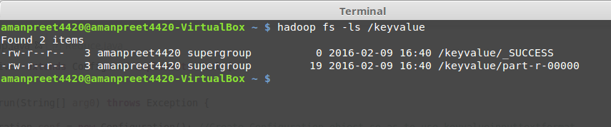

* + - _SUCCESS: this is a flag file, stating that the operation was successful
    - part-r-00000: this is the files containing the final output.
      * Note that there is just one file created, as the number of reducer is 1
  + Content of part-r-00000 file are below:  
    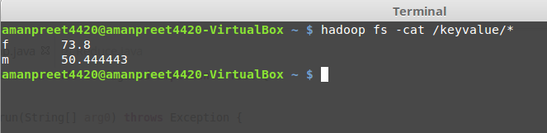
* Let’s change this Job to use two Reducers
  + In the Driver file, put below statement:

job.setNumReduceTasks(2);

* + Run the project and push output in */keyvalue1*. We get below output

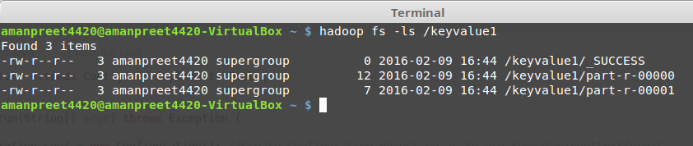

* + Content of both files are below:

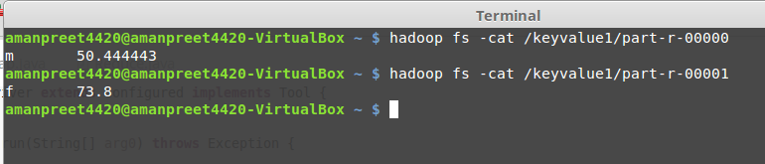

Note here that based on the default Partition logic, all males goes to one reducer and all females goes to the second reducer.

Next we will implement Custom Partition Logic.